

Legal Page
This sample business plan has been made available to users of Bplans.com, published by Palo Alto Software. Our sample plans were developed by existing companies and new business start-ups as research instruments to determine market viability, or funding availability. Names, locations and numbers may have been changed, and substantial portions of text may have been omitted to preserve
confidentiality and proprietary information.
You are welcome to use this plan as a starting point to create your own, but you do not have permission to reproduce, resell, publish, distribute
or even copy this plan as it exists here.
Requests for reprints, academic use, and other dissemination of this sample plan should be emailed to the marketing department of Palo Alto Software at marketing@paloalto.com.

Copyright Palo Alto Software, Inc., 2020 All rights reserved.

Confidentiality Agreement
The undersigned reader acknowledges that the information provided by _______________ in this business plan is confidential; therefore, reader agrees not to disclose it without the express written permission of _______________.
It is acknowledged by reader that information to be furnished in this business plan is in all respects confidential in nature, other than information which is in the public domain through other means and that any disclosure or use of same by reader, may cause serious harm or damage to _______________.
Upon request, this document is to be immediately returned to _______________.
___________________
Signature
___________________
Name (typed or printed)
___________________
Date
This is a business plan. It does not imply an offering of securities.

1.0 Executive Summary 1
1.1 Mission 2
1.2 Objectives 2
1.3 Keys to Success 2
Chart: Highlights 3
2.0 Company Summary 3
2.1 Company Ownership 4
2.2 Company History 4
Table: Past Performance 5
Chart: Past Performance 6
3.0 Products 6
4.0 Market Analysis Summary 7
4.1 Market Segmentation 7
Table: Market Analysis 7
Chart: Market Analysis (Pie) 8
4.2 Target Market Segment Strategy 8
4.3 Industry Analysis 9
4.3.1 Competition and Buying Patterns 9
5.0 Strategy and Implementation Summary 9
5.1 Competitive Edge 10
5.2 Marketing Strategy 10
5.3 Sales Strategy 11
5.3.1 Sales Forecast 11
Table: Sales Forecast 12
Chart: Sales Monthly 12
Chart: Sales by Year 13
6.0 Web Plan Summary 13
6.1 Website Marketing Strategy 13
6.2 Development Requirements 14
7.0 Management Summary 14
7.1 Personnel Plan 14
Table: Personnel 15
8.0 Financial Plan 15
8.1 Important Assumptions 15
Table: General Assumptions 16
8.2 Business Ratios 16
8.2 Business Ratios 16
Table: Ratios 17
8.3 Break-even Analysis 18
8.3 Break-even Analysis 18
Table: Break-even Analysis 18
Chart: Break-even Analysis 18
8.4 Projected Profit and Loss 19
Chart: Profit Monthly 19
Chart: Profit Yearly 20
Chart: Gross Margin Monthly 20
Chart: Gross Margin Yearly 21
Table: Profit and Loss 21
8.5 Projected Cash Flow 22
8.5 Projected Cash Flow 22
Table: Cash Flow 22
Chart: Cash 23
8.6 Projected Balance Sheet 24
Table: Balance Sheet 24
Table: Sales Forecast 1
Table: Personnel 2
Table: Personnel 2
Table: Profit and Loss 3
Table: Profit and Loss 3
Table: Cash Flow 4
Table: Cash Flow 4
Table: Balance Sheet 6
Table: Balance Sheet 6

1.0 Executive Summary
G-T Enterprises is owned by E. Gwen Hultquist and her husband, Timothy A. Hultquist. While primarily operating the Web store, Grapevine Country Gifts at www.grapetime.com, the owners are also vendors at consumer gift shows, home and garden expositions, summer fairs and festivals; these events help us to promote the Web store. By the end of the third season, both online visitors and purchases have increased significantly over the previous year, despite the difficulties of a slow recovery of the national economy.
The owners of G-T Enterprises believe that continued growth of the business can be accomplished with:
- Serious revamping of the Web store (already in progress) and increased promotions;
- Sponsoring special community events and fund raisers for local organizations;
- Renovation of an existing building to safely store inventory and set up a more efficient packing and shipping area;
- Increasing the number of shows/events aimed at upscale consumers;
- Purchasing seasonal and regular inventory in larger quantities for better price breaks.
While the sales growth has been anticipated and welcomed, it has come a little late for financial recovery of debts incurred to reach this point. We need financing to renovate the existing storage space (our barn), alleviate the outstanding debts and release credit lines for product purchases and advance payments that are required for space rental at shows, festivals and other market events. In addition, financing will prevent us from missing opportunities for obtaining and selling "ground floor" products before they become available by other merchants on the travel show circuit.
In the local community, there are limited opportunities for unskilled employment for young people. We expect to hire high school students for stocking, packing, shipping, and training on other business activities. These students can benefit from our experience and education, and we hope to be role models for them, encouraging them to further their education or pursue their ambitions of entrepreneurship. In addition, we will be sponsoring special events (i.e., "SummerFest," 4th of July activities) and fund raisers for local organizations (schools, churches, other groups).
Our two main suppliers manufacture in the United States, so our sales are contributing to keeping jobs in America. We continue to seek out and direct-buy American-made products that we can offer at reasonable prices and receive a fair profit. We also have potential resources, with adequate funding, to obtain quality and highly saleable merchandise appropriate for fundraisers.
We are seeking $40,000 in long-term loans to finance renovation and restoration of the existing barn for use as a warehouse, and to maintain positive cash balances throughout the months we are occupied with the renovation.

1.1 Mission
Company Mission
Grapevine Country Gifts is a celebration of the home. Our mission is to provide unique and affordable home accents and gifts for the quality- and style-conscious consumer. We will make our products easily accessible with a presence online and at various shows and festivals.
Customer Creed
Grapevine Country Gifts takes pride in its customer service, good communication, and guaranteed satisfaction of consumers' purchases.
Employee Pledge
Our employees will enjoy a friendly and fair work environment, which rewards hard work and offers opportunities for training in a variety of business activities.

1.2 Objectives
- Continue to provide unique quality home and gift products at reasonable prices on the Internet and at consumer home/gift shows;
- Generate minimum total revenues of $125,000 by the end of year one;
- Expand and maintain Web store to increase revenues to create attractive purchase by year five;
- Realize an annual growth of approximately 45% in year two;
- Realize an annual growth of approximately 20% in year three and each year thereafter;
- Establish a following of customers in a specific road show circuit of 24-36 shows per year: Home & Garden Shows, Shipshewana On The Road, Summer Festivals/Arts & Crafts Shows;
- Seek out additional quality products to include in our product mix.

1.3 Keys to Success
The primary keys to success for the company will be based on the following factors:
- Home based facilities that reduce overhead expenses and maximize profit margins.
- Products that provide quality and value to the consumer while meeting needs for an expression of personal style.
- Customer services, such as obtaining obscure and discontinued products (specifically Spoontiques Pin Art and Ear Art), and personalized promotions, so that customers are encouraged for repeat purchases and make referrals.
- Communication with our customer base through email and postcard mailings.
- A visible, accessible and welcoming Web store to position us as the preferred choice for our products and services within the marketplace on the Internet and local communities in our 4-state region.
- Practice of daily management tactics, so that a successful and growth-oriented business is developed and maintained.

Chart: Highlights
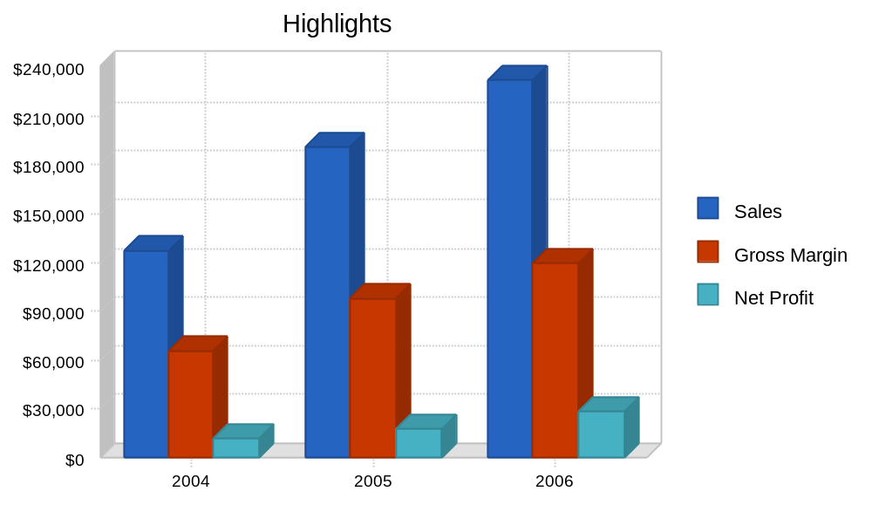

2.0 Company Summary
Grapevine Country Gifts is an Internet-based Web store spun off by G-T Enterprises. It began as an experiment for the design of an e-commerce site after a G-T customer refused to pay for development of a similar site because, "it wasn't making any money," within the first four days of implementation. Launched in January of 2000, the site was submitted to search engines about four months before search engines began charging for submission. Even though the site began attracting visitors, sales were slow at first, due in part to an inadequate (but costly) payment processing system which has since been replaced. With this early system we often had to meet suppliers' minimum order requirements in order to fill a single customer's order, as inventory levels were being built.
Our new system is much more efficient, and the higher sales volume we are now processing has streamlined our inventory management. Last year's sales revenues were more than 6 times higher than sales the year before that. We expect continued growth, at a much slower pace, in the foreseeable future.

2.1 Company Ownership
G-T Enterprises is currently a partnership owned by the married couple E. Gwen Hultquist and Timothy A. Hultquist. Gwen Hultquist is the majority owner and manager for both G-T Enterprises and Grapevine Country Gifts. Tim Hultquist is sole owner and manager of Technical Computer Support (TCS), a small-business computer consulting company for sales, installation, integration, networking, maintenance, and support, which is not part of this business plan. The owners both hold Bachelor of Business Degrees from Western Michigan University, Kalamazoo, Michigan and have had several years' of management experience prior to self-employment.
This business plan is based upon the consolidation of Grapevine Country Gifts (the Web store) into the pre-existing G-T Enterprises, which has so far focused on selling similar products through road shows. These endeavors are very similar, and combining them under the same company will greatly simplify our financial and marketing strategies, by treating them as different revenue streams in a unified plan. The larger G-T Enterprises will remain a partnership between the Hultquists, with Gwen as the majority owner.

2.2 Company History
G-T Enterprises began in 1999 as a website consultation, design and development firm for small- to medium-sized businesses. Various events led to the addition of the Web store, "Grapevine Country Gifts and Collectibles" (now simply, "Grapevine Country Gifts"), selling primarily Pin Art, Ear Art and miniature lighthouse replicas by Spoontiques©. We added hand painted Artistic Glass by Artistic Gifts© and other miscellaneous products from various vendors. In the spring of 2002, as a means of promoting the Web store, we began exhibiting and selling our products at consumer gift shows and home shows in a four-state area. "Newbies" in this area of commerce, the first show was a complete bust with the exception of gaining valuable experience in evaluating shows and developing organizational skills for setup and booth layout.
Operations of the business are conducted on our 100-year-old family farmstead, now reduced to approximately five acres. A 16' x 24' barn and a smaller antique outbuilding were converted and renovated for office/work shops. The three-story barn was re-roofed in 1995, along with the house. It is structurally sound, but requires extensive restoration and renovation for use as storage for product warehousing, packing and shipping. The home-based operations greatly reduce our overhead expenses and a fair portion of utilities and other related household expenses can be charged as business expense.
G-T Enterprises' start-up capital of $1,000 was originally provided by E. Gwen Hultquist. Her husband, Timothy A. Hultquist, has, among other things, supported the company financially, mostly by providing 'no-interest' short-term loans to cover working capital requirements. At the starting year of the current business plan (FY2004), Mr. Hultquist has provided a total of $20,000 of no-interest loans that need to be repaid within three years.

Table: Past Performance

Past Performance
 | 2001 | 2002 | 2003
Sales | $3,506 | $13,110 | $85,325
Gross Margin | $1,000 | $4,000 | $44,369
Gross Margin % | 28.52% | 30.51% | 52.00%
Operating Expenses | $5,000 | $8,000 | $16,212
Inventory Turnover | 2.34 | 6.56 | 5.07
Balance Sheet
 | 2001 | 2002 | 2003
Current Assets
Cash | $500 | $2,500 | $13,653
Inventory | $1,500 | $2,500 | $6,000
Other Current Assets | $0 | $0 | $0
Total Current Assets | $2,000 | $5,000 | $19,653
Long-term Assets
Long-term Assets | $2,350 | $2,350 | $12,555
Accumulated Depreciation | $200 | $200 | $1,200
Total Long-term Assets | $2,150 | $2,150 | $11,355
Total Assets | $4,150 | $7,150 | $31,008
Current Liabilities
Accounts Payable | $0 | $659 | $1,201
Current Borrowing | $0 | $0 | $0
Other Current Liabilities (interest free) | $8,000 | $22,000 | $20,000
Total Current Liabilities | $8,000 | $22,659 | $21,201
Long-term Liabilities | $0 | $0 | $0
Total Liabilities | $8,000 | $22,659 | $21,201
Paid-in Capital | $1,000 | $1,000 | $1,000
Retained Earnings | ($4,850) | ($16,509) | ($19,350)
Earnings | $0 | $0 | $28,157
Total Capital | ($3,850) | ($15,509) | $9,807
Total Capital and Liabilities | $4,150 | $7,150 | $31,008
Other Inputs
Payment Days | 0 | 0 | 0

Chart: Past Performance
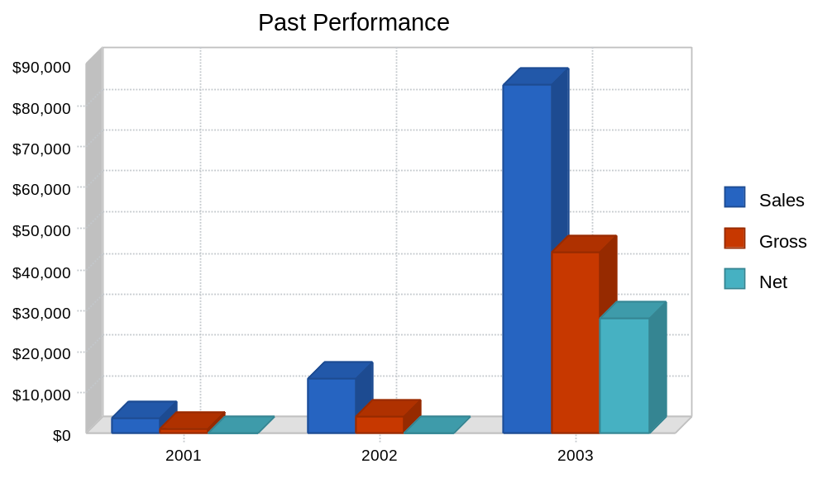

3.0 Products
Grapevine Country Gift's product line is extensive. We offer basically the entire Spoontiques vendor catalog of several thousand items, although we concentrate on several popular designs of Pin Art, Ear Art, step stones, and other unique items. Artistic Gifts has many designs of art glass in seven sizes, most of which are featured on the Web store. Because of the large quantity of items and styles, it is not feasible to inventory all products; our website features those products we know to be bestsellers. However, any of these items can be purchased from Grapevine Country by special order, either at shows, by phone, or online. Artistic Gifts will drop-ship for a nominal fee.
Because of the relatively long lead time between a customer's order, arrival of the goods and subsequent shipment to the customer, Grapevine Country has found that certain items maintain a marked popularity and we stock these items ready for immediate shipment. Wholesale value of inventory is approximately $6,000 at any given time. G-T Enterprises constantly searches for unique products that will offer value, fun, and appeal based on interests shown at shows and search strings in the Web store statistics.
Our products focus on personal style and interests. Spoontiques Pin Art and Ear Art are novel theme-based designs that excite buyers to purchase either for themselves or as gifts for someone else. The monkey and moose earrings are bestsellers, with anything in frogs or cats following closely. Our secondary product lines change as we find exceptional values. Summer show products are concentrated on products for the entire family and children as well as the home and garden décor and personal gifts.

4.0 Market Analysis Summary
Our target market is women over age 40, with household income over $60,000. With high disposable income, mature adults (empty nesters) redecorate their homes to reflect their tastes more than was possible when there were young children in the home.
Last year in the U.S., female consumers produced the highest growth rate in online sales, accounting for 52% of online purchases, an increase of 5% over 2002. Nearly 54% of those purchasers are in our target age group. Gifts and flower sales online were up 56% this holiday over last. Home and garden purchases were the top category in the 2003 holiday buying season, experiencing a 27.9% increase over 2002. This female target market is the primary purchaser of household gifts and home décor. The mature audience shopping online is expected to increase by 16%, compounded, per year through 2008. (Network World Fusion, Jan, '04, U.S. 2000 Census; Jupiter Research, Feb,'04)

4.1 Market Segmentation
As stated above, the company's target audience is women over 40 with a household income over $60,000. In terms of sales channels, we believe that about half of our target clientele will be reached through our website, with the other half split between the ones we reach via our participation in road shows and special events. We also forecast that the pool of potential web clients will grow at the fastest rate (at 20% annually), while the client base for road shows and special events will be growing at 15% and 10%, respectively, as summarized in the table below.

Table: Market Analysis

Market Analysis
 |  | 2004 | 2005 | 2006 | 2007 | 2008
Potential Customers | Growth |  |  |  |  |  | CAGR
Web Sales | 20% | 76,093 | 91,311 | 109,573 | 131,488 | 157,786 | 20.00%
Road Shows | 15% | 40,500 | 46,575 | 53,561 | 61,595 | 70,834 | 15.00%
Special Events | 10% | 36,000 | 39,600 | 43,560 | 47,916 | 52,708 | 10.00%
Total | 16.53% | 152,593 | 177,486 | 206,694 | 240,999 | 281,328 | 16.53%

Chart: Market Analysis (Pie)
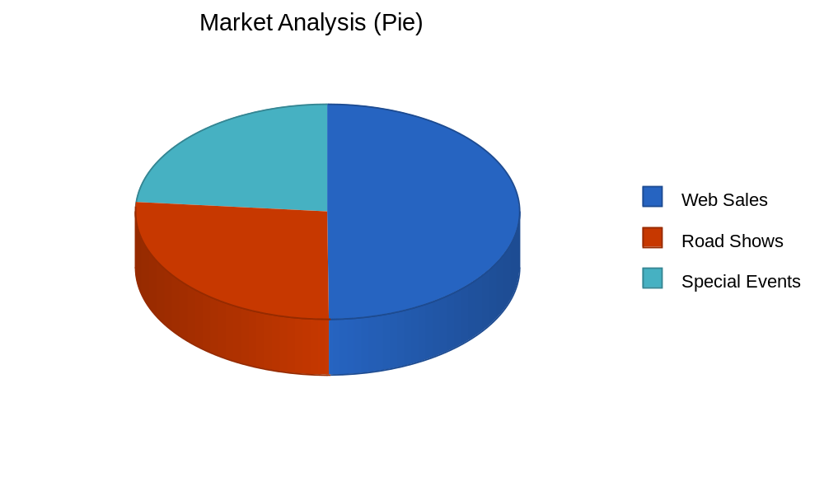

4.2 Target Market Segment Strategy
We know that the target market segment we have selected is already predisposed to seek out our products. Comfortably well-off women over 40 make up most of those attending home and garden and other shows at which we exhibit our products. Our presence at these shows has increased monthly visits to our website by 413% in the past year.
While online purchases by women over 40 continue to rise, publications by Jupiter Research in February, 2004, project that similar women over 60 will be expanding their Internet experience and expenditures at even higher rates in the near future. By expanding our presence on other shopping sites, we will continue to increase our access to this group. Linking with other popular sites through a LinkShare program will not only provide additional revenues with "click-through" purchases, but associate Grapevine Country Gifts with other quality merchants on the Internet frequented by our target market.
Market Needs
Home redecoration allows women to reflect their tastes and use their creativity to make their homes truly special to them. Quite often this means that a woman looks for some rare, limited-edition item that will bring comfort to her home and peace in her mind. Although home decor products are carried by many retailers, out-of-stock items are hard to find, since few stores special-order items. While a few hard core collectors find the thrill of searching for rare items appealing, most of our customers who would like to decorate their homes favor convenient ordering and reasonable prices.

4.3 Industry Analysis
Post-2003 retail sales reports indicate that economic concerns and comfort levels for buying on the Internet are improved. Holiday sales, exceeding projections, were up 29.5% over 2002 – reaching $12.5 billion (excluding travel and auctions). (Network World Fusion, Jan. '04) Although predictions for retail sales growth in 2004 are a little slow in coming, the recovery can be seen in sales bursts on the web and increased sales at Spring shows.

4.3.1 Competition and Buying Patterns
Competition for jewelry and home décor is stringent on the Internet and at consumer shows. Many online and traveling merchants have been in existence for a longer period and have established recognition. Our products are also carried in fine gift shops, such as Hallmark stores, and in major department stores. Many of our competitors have additional advantages because of their greater size, which allows them to more easily absorb losses on unpopular products.
Our targeted consumers are seeking convenience and value in their purchases. They want a wide selection to reflect their own individual styles, and easy purchase processes at good prices. Our switch to an easier payment process has shown how important it is to our customers to have a secure, transparent, and reliable purchase process with good customer service. This one change is responsible for at least half the strong sales growth we have seen in the last year.
Customers who come to shows and festivals where we exhibit are also seeking convenience and value, but our competition at these shows is largely the other vendors. A potential customer arrives with at least a subconscious notion of how much she is willing to spend, and on what, while at the event. Sales made by other vendors are money taken out of our pockets. Competition here is about value, attractiveness of displays, good selection, and friendly, in-person interactions.

5.0 Strategy and Implementation Summary
We will focus our strategic efforts on promoting sales through our website. We see our key target audience as women over 40 years with disposable income of over $60,000. Customer reach will be increased by advertising with the main search engines. Our sales message will emphasize customer service and communication. We will do our best to source products for customers' orders by further strengthening our relationships with key suppliers, such as Spoontiques and Art Glass. Our website will be promoted through participation in key shows and exhibitions, where we will strive to establish rapport with our key target audience and ensure repeat sales.

5.1 Competitive Edge
Our competitive edges are our popularity, accessibility, flexibility, and ability to deliver. Any search engine brings up Grapevine Country in the top 5-10 listings on the search string, "Spoontiques Pin Art," and we are beginning to be found by searchers for Art Glass. We are developing a customer base and followers (called "groupies" by one show promoter) to our shows. Previous year's customers have returned for additional purchases. Our marketing strategy will enforce and enhance our competitive edge for additional growth.
Our main competitive edge over gift chains and retail stores is our ability to deliver out-of-stock and hard to find items through special ordering. In addition, our website is more navigable and friendly than those of most large stores who carry similar products as a side-line. Our focus on home decor and jewelry allows us to highlight entire collections that get short shrift on competitors' online listings.

5.2 Marketing Strategy
Road shows and festivals were originally a means of promoting the Web store and will continue as such until the demands of the Web store reach our goals. Despite the travel and hard work involved, as "people persons," the opportunity of meeting customers face-to-face has been profitable. Even though the Artistic Glass has been sold in upscale gift stores for more than 10 years, many people are seeing it for the first time. Our show schedule is maintained on the Web store and customers seek us out when we exhibit in their area or, as it has happened, within a 2-hour drive. When possible, discount coupons for show purchases are sent to customers in regions of upcoming shows. Scented Roses tagged with the Web store URL and coded discount coupon on their next online purchase are presented to selected customers. We are purchasing "pay-per-click" listings on affordably-priced shopping websites (www.shopping.com and www.business.com) and expect to upgrade to shopping directory at www.Yahoo.com by the end of the year. These expenses are not reflected in the attached financial projections as the number of clicks are difficult to project at this point. However, the cash flow projections indicate there are sufficient funds to proceed.

5.3 Sales Strategy
We focus a large amount of energy on customer service and communication. The fact that we are often able to obtain out-of-stock, retired/terminated, or hard to find Spoontiques Pin Art is based on the great rapport we have with the company. We frequently receive referrals from Spoontiques, as well, because they know we stock many of the popular pieces that the general public cannot buy directly from the company. There have only been three instances in two years when a product was completely unavailable. We also special order items for a customer, a service not generally provided by gift stores or other sources.
We offer our customers multiple secure payment processing options, so they can use whichever process they feel most comfortable with. Customers placing orders by phone are extended every courtesy and can count on receiving quality products at a fair price. We also have an order form online that can be faxed to our office.
Payment options on the Web store started with an online credit card processing that proved to be costly, with too few sales in the beginning to be financially prudent. PayPal added merchant accounts to their program, and when our shopping cart provided a PayPal gateway, we switched. Unfortunately, PayPal was also a discouraging and difficult transaction facilitator, and several sales were lost until we emailed or called to offer alternative payment options. (PayPal recently upgraded and improved their program but it is less frequently used than our offline processing.)
In early Spring of 2003, the shopping cart was upgraded to allow offline processing (manually, on our company credit card terminal) and sales soared. We provide additional payment options – checks and money orders, since there are still people concerned about providing their personal information on the Internet or over the phone. However, shipments on the non-credit card paid orders are dispatched only once funds are collected, so for cash flow planning purposes, all sales are treated as cash sales.

5.3.1 Sales Forecast
2003 was our first profitable year, producing expectations of continued growth. We believe that our new payment options and marketing strategies will produce continued growth over the next three years, although probably not at the same explosive rate.
Based on current trends, and our own sales results, we are forecasting almost 50% growth next year, with continued high growth in online sales, and slower growth rates for our other revenue streams.
Our break-even point was based on an average sale of $21 at shows and $27 on the Web store. By increasing the incentives and awareness through promotion, we expect to raise the average sale to $35. The spring shows and sales have been a little disappointing due to consumers' concerns about the economy. However, while attendance at road shows is down, visits to the Web store have increased. We were able to establish 4 new web design clients which assisted cash flow.
Sales in the first quarter will be slow, as we begin preparations for renovating the barn and working out of an alternate site on our property during construction. We will be able to return full-time attention to generating sales in April.

Table: Sales Forecast

Sales Forecast
 | 2004 | 2005 | 2006
Sales
Web Sales | $59,341 | $93,758 | $117,198
Road Shows | $57,200 | $82,368 | $98,842
Web Design | $11,000 | $14,630 | $16,093
Total Sales | $127,541 | $190,756 | $232,132
Direct Cost of Sales | 2004 | 2005 | 2006
Web Sales | $26,644 | $42,097 | $52,622
Road Shows | $34,320 | $49,421 | $59,305
Web Design | $748 | $995 | $1,094
Subtotal Direct Cost of Sales | $61,712 | $92,513 | $113,021

Chart: Sales Monthly
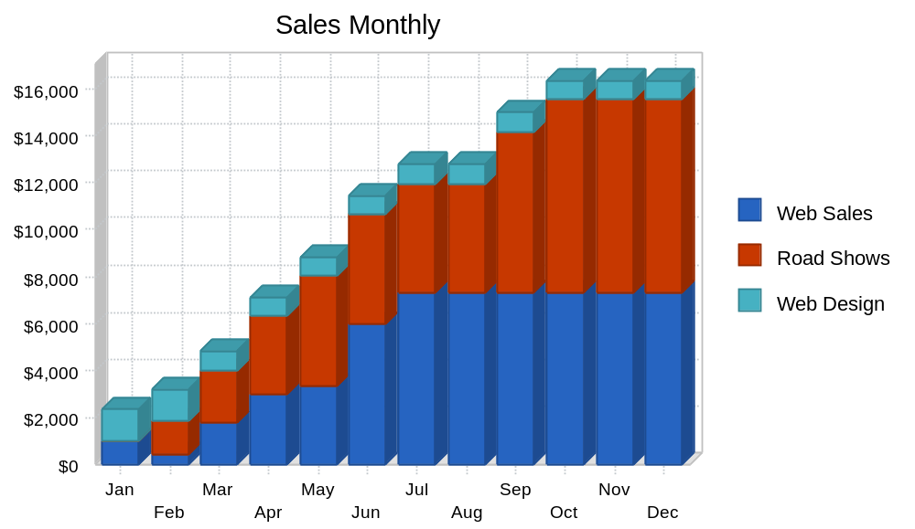

Chart: Sales by Year
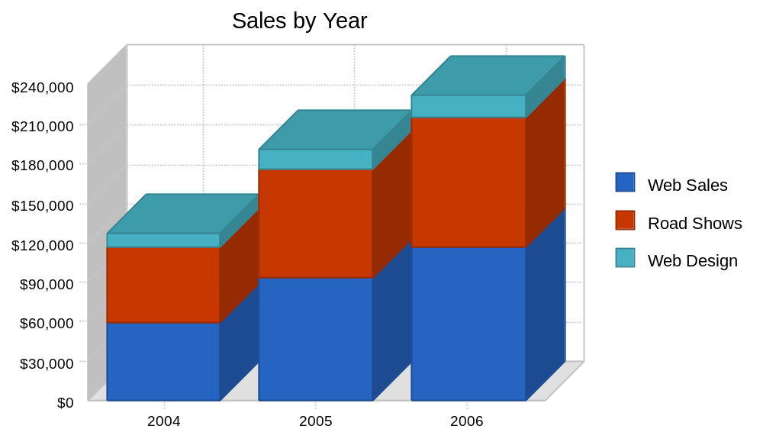

6.0 Web Plan Summary
Our website (www.grapetime.com) is currently producing the largest revenue stream of all Grapevine and G-T Enterprises' endeavors. After initial difficulties with payment processing, we enabled offline payments (phone, fax, money orders, and checks) and saw immediate and dramatic changes in completed sales. We will continue to offer these multiple payment options while highlighting the website as our online showroom/catalogue. Our website offers the flexibility of changing our listings as soon as our suppliers release new products. There is no time waster waiting for printing, and no expense to absorb for obsolete catalogues.
We will expand awareness of our Web store with increased online marketing. We will place banner ads on sites popular with our target market, and "pay-per-click" advertising with sites hosted by our suppliers (Spoontiques, Artistic Glass, etc.).

6.1 Website Marketing Strategy
Since our primary sales are from the Web store, fundamental efforts will be concentrated on drawing buying visitors to the website. Special enticements to convert the general browser to purchase will be implemented. Some of these strategies include:
- Executing a simple and quick exit survey when no purchase occurs, to determine what deterred a potential customer from purchasing.
- Offering e-mail sign-up notification, where e-mail address is never shared with any third party for any reason, of new products and special offers or seasonal savings.
- Offering first-time customers a coupon discount on their next online (including phone or fax) order for referring a friend who makes a purchase online.
- Shipping free or breaks on purchases over $50.
- Listing the Web store on specific shopping sites (pay-per-click) for shopper leads.

6.2 Development Requirements
The Web store is established and in the process of functional upgrade. Payment processing options are in place and working efficiently. The shopping cart, which costs $200 per year, is upgraded for more benefits and is probably one of the easiest carts to navigate on the Internet. Cooperative linking will be increased and is currently effective in producing additional indexing by search engines. We have set up our own web host service which is paid for by current web design customers. We have joined a linkshare program that earns a commission on purchases made by customers clicking through our site. All our web design customer sites have links to our store, many have other external reciprocal links with other sites.

7.0 Management Summary
The owners, Gwen and Tim Hultquist, have had several years of management and business experience prior to self-employment. Ms. Hultquist was project administrator for an educational grant at a local university, overseeing annual budgets of several hundred thousand dollars over 10 years. She has operated the Web store for three years, bringing it to profitability in 2003. Mr. Hultquist was a production manager supervising several dozen employees at a technical electronics manufacturing company for seven years until the company was purchased by a foreign entity. He has been conducting his business of computer consulting since 1992, experiencing an annual growth of approximately 30%. He contributes objectivity, technical support, and in the first two years, financial support to the business. [Technical Computer Support operates separately from Grapevine Country/G-T Enterprises and is not an instrumental part of this business plan.] Both have Bachelor of Business Administration degrees, with honors, from Western Michigan University.

7.1 Personnel Plan
The personnel goal of the business is to provide employment opportunities to 8th to 12th grade students for after school and occasional weekends when we are not participating at shows. These students would be utilized primarily for packing and shipping web orders, unpacking and storing inventory, doing data entry for invoices and other non-private information processing computer activities. We would also employ certain students for lawn care and assisting in making the grounds more presentable to visitors and/or customers. Some shows are within daily driving distance, not requiring overnight accommodations and occasionally desirable shows occur on the same weekend. We would be able to "double-book" same-date shows with a competent assistant for break relief. Each individual would need to be adept at operating a cash register and handling cash, and also processing check and credit card transactions.
We expect turnover to be considerable due to conflicts of extra-curricular activities and personal schedules, as well as times when a student employee simply does not work out. Student employees would be paid a little better than minimum wage and receive additional benefits since they would not be eligible for insurance, etc.
It may be necessary to employ additional staff on a seasonal basis from time to time. Such will be determined on an as-needed basis.

Table: Personnel

Personnel Plan
 | 2004 | 2005 | 2006
Gwen Hultquist, Owner/Manager | $12,000 | $12,000 | $12,000
Tim Hultquist, Co-Owner | $12,000 | $12,000 | $12,000
General Labor | $7,224 | $33,280 | $39,936
Total People | 4 | 5 | 6
Total Payroll | $31,224 | $57,280 | $63,936

8.0 Financial Plan
This section outlines our financial goals. Our plan is to maintain a 50% gross margin and a net margin of 6-9% (after the first quarter of 2004, once barn renovations are complete). This should allow us to remain profitable and have a solid cash flows that will help us repay both our long-term loan and the no-interest loans extended by the owner's husband, and to steadily grow the net worth of this business.
The Profit and Loss statement shows our operating expenses, including portions of the mortgage and utilities for business-only areas and usage. Our general marketing expenses are low, because most of our sales are currently being generated through personal contacts at events, and by word of mouth about our website. We are allocating roughly $500 per year for increased online marketing, which our research indicates will be sufficient for reaching our target market. We project net profit rebounding soon after property renovations are completed.
The Cash Flow shows our loan repayments, as well as money to be spent on barn renovations (as increased asset value). The long-term loans we are seeking will help us to maintain a positive Cash Balance while performing needed work on our storage area (the barn) and increasing sales.
The Balance Sheet shows our increasing net worth over the next three years, as we pay off loans, increase assets, and retain greater earnings within the business.

8.1 Important Assumptions
Our financial model is build on the following assumption:
- All capital assets are depreciated on a 10-year, straight-line basis
- No-interest loans provided by Mr. Hultquist in the total outstanding amount of $20,000 will be fully repaid within three years ($6,670 per year)
- Long-term loans at 7% interest will be repaid within 8 years.
- For cash flow planning purposes, all sales are treated as cash (no accounts receivable).

Table: General Assumptions

General Assumptions
 | 2004 | 2005 | 2006
Plan Month | 1 | 2 | 3
Current Interest Rate | 6.50% | 6.50% | 6.50%
Long-term Interest Rate | 7.00% | 7.00% | 7.00%
Tax Rate | 30.00% | 30.00% | 30.00%
Other | 0 | 0 | 0

8.2 Business Ratios
The table below summarizes our key business ratios and includes industry averages for comparison. Industry data comes from the "Gift, Novelty, and Souvenir Shops" industry (SIC Code 5947). Unlike most gift and small-art item retailers, the majority of our sales are online, so our asset and inventory ratios are unusual.
As we accumulate cash and reduce loans, our solvency ratios will significantly improve. Since the bulk of our products will be sourced after we receive customer orders, our inventory levels of most popular items will be below the industry average ranges.

Table: Ratios

Ratio Analysis
 | 2004 | 2005 | 2006 | Industry Profile
Sales Growth | 49.48% | 49.57% | 21.69% | 0.24%
Percent of Total Assets
Inventory | 11.38% | 17.42% | 14.47% | 37.46%
Other Current Assets | 0.00% | 0.00% | 0.00% | 22.92%
Total Current Assets | 40.55% | 46.38% | 56.89% | 77.62%
Long-term Assets | 59.45% | 53.62% | 43.11% | 22.38%
Total Assets | 100.00% | 100.00% | 100.00% | 100.00%
Current Liabilities | 29.13% | 19.26% | 11.07% | 35.33%
Long-term Liabilities | 43.70% | 34.43% | 22.88% | 14.48%
Total Liabilities | 72.83% | 53.69% | 33.96% | 49.81%
Net Worth | 27.17% | 46.31% | 66.04% | 50.19%
Percent of Sales
Sales | 100.00% | 100.00% | 100.00% | 100.00%
Gross Margin | 51.61% | 51.50% | 51.31% | 40.09%
Selling, General & Administrative Expenses | 280.78% | 0.00% | 0.00% | 24.66%
Advertising Expenses | 0.00% | 0.00% | 0.00% | 1.85%
Profit Before Interest and Taxes | 15.43% | 14.60% | 18.12% | 2.19%
Main Ratios
Current | 1.39 | 2.41 | 5.14 | 1.96
Quick | 1.00 | 1.50 | 3.83 | 0.78
Total Debt to Total Assets | 72.83% | 53.69% | 33.96% | 53.68%
Pre-tax Return on Net Worth | 78.46% | 64.50% | 59.29% | 3.96%
Pre-tax Return on Assets | 21.32% | 29.87% | 39.15% | 8.55%
Additional Ratios | 2004 | 2005 | 2006
Net Profit Margin | 9.37% | 9.39% | 12.12% | n.a
Return on Equity | 54.92% | 45.15% | 41.50% | n.a
Activity Ratios
Inventory Turnover | 9.29 | 7.70 | 7.59 | n.a
Accounts Payable Turnover | 8.63 | 12.17 | 12.17 | n.a
Payment Days | 28 | 30 | 28 | n.a
Total Asset Turnover | 1.59 | 2.23 | 2.26 | n.a
Debt Ratios
Debt to Net Worth | 2.68 | 1.16 | 0.51 | n.a
Current Liab. to Liab. | 0.40 | 0.36 | 0.33 | n.a
Liquidity Ratios
Net Working Capital | $9,150 | $23,229 | $47,038 | n.a
Interest Coverage | 7.54 | 12.34 | 22.67 | n.a
Additional Ratios
Assets to Sales | 0.63 | 0.45 | 0.44 | n.a
Current Debt/Total Assets | 29% | 19% | 11% | n.a
Acid Test | 1.00 | 1.50 | 3.83 | n.a
Sales/Net Worth | 5.86 | 4.81 | 3.42 | n.a
Dividend Payout | 0.00 | 0.00 | 0.00 | n.a

8.3 Break-even Analysis
Assuming variable costs of 48% our analysis shows that to break-even we need to have monthly revenues as summarized in the table and chart below. After barn renovations are complete, we should surpass that sales volume by May of 2004.

Table: Break-even Analysis

Break-even Analysis
Monthly Revenue Break-even | $7,451
Assumptions:
Average Percent Variable Cost | 48%
Estimated Monthly Fixed Cost | $3,846

Chart: Break-even Analysis
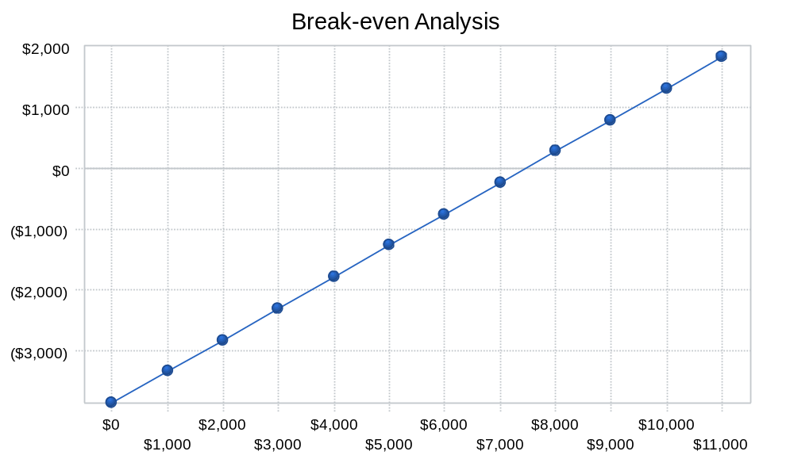

8.4 Projected Profit and Loss
The table below shows our profit and loss projections. Although we expect to sell some higher margin products in the first months of 2004, we expect that our overall gross margin will stabilize at around 50%. We believe that our new strategy will allow us to average a healthy net margin in 2004, which will eventually stabilize over the next two years.

Chart: Profit Monthly
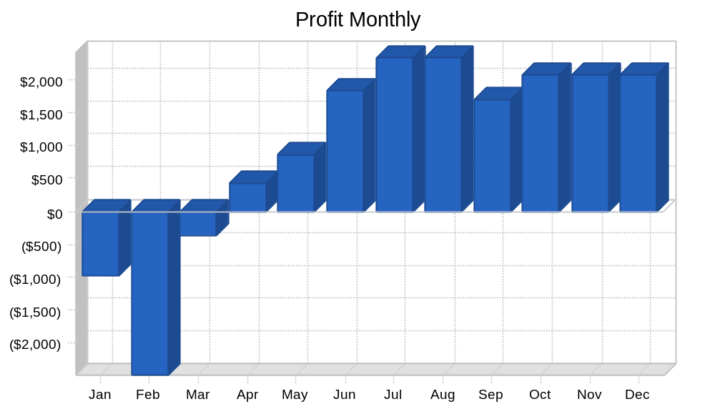

Chart: Profit Yearly
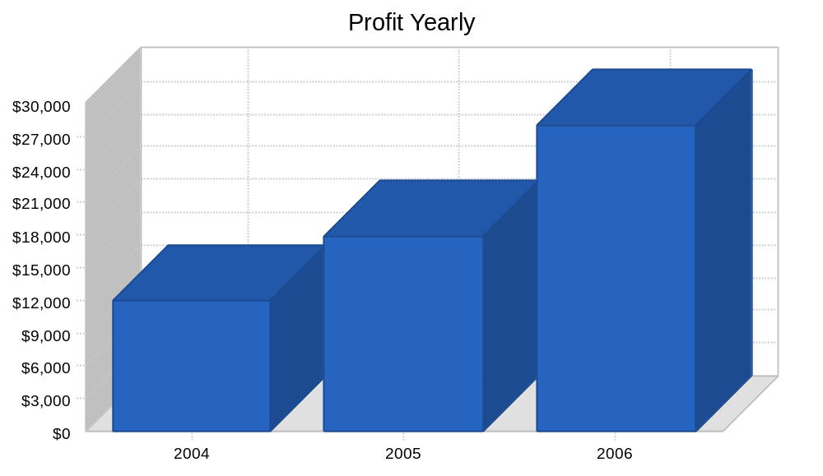

Chart: Gross Margin Monthly
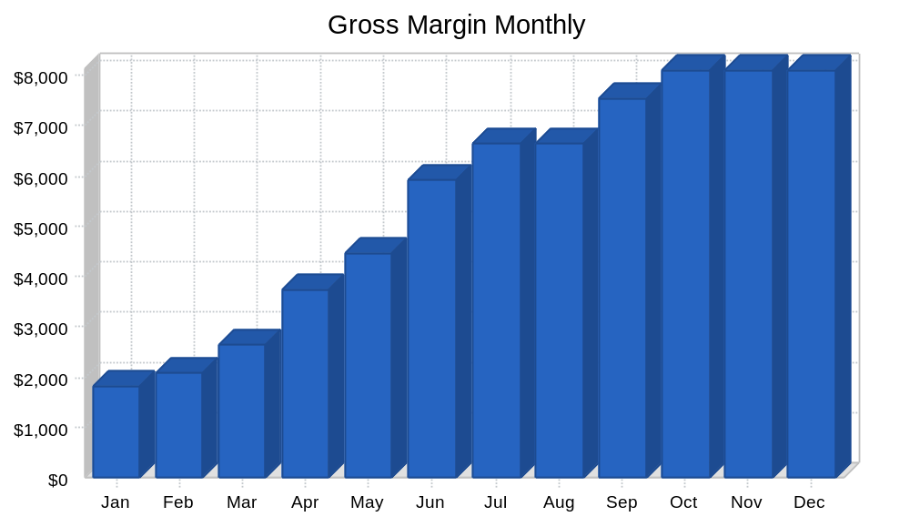

Chart: Gross Margin Yearly
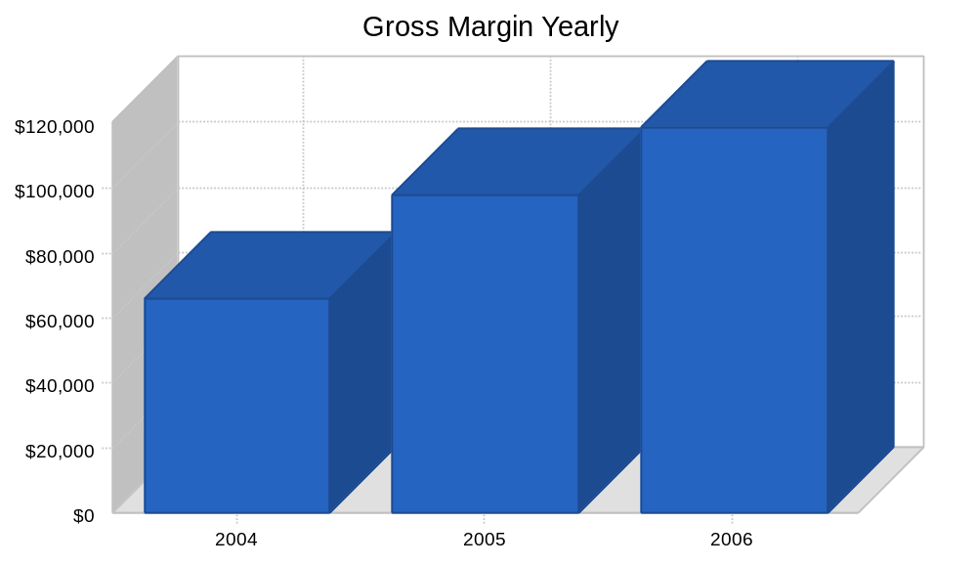

Table: Profit and Loss

Pro Forma Profit and Loss
 | 2004 | 2005 | 2006
Sales | $127,541 | $190,756 | $232,132
Direct Cost of Sales | $61,712 | $92,513 | $113,021
Other Costs of Goods | $0 | $0 | $0
Total Cost of Sales | $61,712 | $92,513 | $113,021
Gross Margin | $65,829 | $98,243 | $119,111
Gross Margin % | 51.61% | 51.50% | 51.31%
Expenses
Payroll | $31,224 | $57,280 | $63,936
Sales and Marketing and Other Expenses | $600 | $600 | $600
Depreciation | $1,252 | $1,669 | $1,669
Mortgage % for Business-only Areas | $4,200 | $4,200 | $4,200
Telephone & Utilities | $3,000 | $3,000 | $3,000
Insurance | $575 | $855 | $855
Payroll Taxes | $0 | $0 | $0
Web Store & Internet | $840 | $840 | $840
Maintenance & Repair | $756 | $756 | $756
Business Supplies | $300 | $300 | $300
Professional Services | $600 | $600 | $600
Expensed Barn Renovations | $2,500 | $0 | $0
Miscellaneous | $300 | $300 | $300
Total Operating Expenses | $46,147 | $70,400 | $77,056
Profit Before Interest and Taxes | $19,682 | $27,843 | $42,056
EBITDA | $20,933 | $29,512 | $43,724
Interest Expense | $2,610 | $2,257 | $1,855
Taxes Incurred | $5,121 | $7,676 | $12,060
Net Profit | $11,950 | $17,910 | $28,141
Net Profit/Sales | 9.37% | 9.39% | 12.12%

8.5 Projected Cash Flow
Our cash flow projections are summarized in the table below. The fact that all of our sales are treated as cash-only helps us avoid possible collection problems. More importantly, growth in sales and profits will allow us to start repaying the no-interest loans that have been extended by the owner's husband, Mr. Hultquist, as well as our long-term loans.
Overall, our new strategy should allow us to end 2004 with a cash level sufficient for smooth inventory management.

Table: Cash Flow

Pro Forma Cash Flow
 | 2004 | 2005 | 2006
Cash Received
Cash from Operations
Cash Sales | $127,541 | $190,756 | $232,132
Subtotal Cash from Operations | $127,541 | $190,756 | $232,132
Additional Cash Received
Sales Tax, VAT, HST/GST Received | $0 | $0 | $0
New Current Borrowing | $0 | $0 | $0
New Other Liabilities (interest-free) | $0 | $0 | $0
New Long-term Liabilities | $40,000 | $0 | $0
Sales of Other Current Assets | $0 | $0 | $0
Sales of Long-term Assets | $0 | $0 | $0
New Investment Received | $0 | $0 | $0
Subtotal Cash Received | $167,541 | $190,756 | $232,132
Expenditures | 2004 | 2005 | 2006
Expenditures from Operations
Cash Spending | $31,224 | $57,280 | $63,936
Bill Payments | $77,434 | $119,865 | $136,791
Subtotal Spent on Operations | $108,658 | $177,145 | $200,727
Additional Cash Spent
Sales Tax, VAT, HST/GST Paid Out | $0 | $0 | $0
Principal Repayment of Current Borrowing | $0 | $0 | $0
Other Liabilities Principal Repayment | $6,670 | $6,670 | $6,660
Long-term Liabilities Principal Repayment | $5,004 | $5,500 | $6,000
Purchase Other Current Assets | $0 | $0 | $0
Purchase Long-term Assets | $37,500 | $0 | $0
Dividends | $0 | $0 | $0
Subtotal Cash Spent | $157,832 | $189,315 | $213,387
Net Cash Flow | $9,709 | $1,441 | $18,745
Cash Balance | $23,362 | $24,803 | $43,548

Chart: Cash
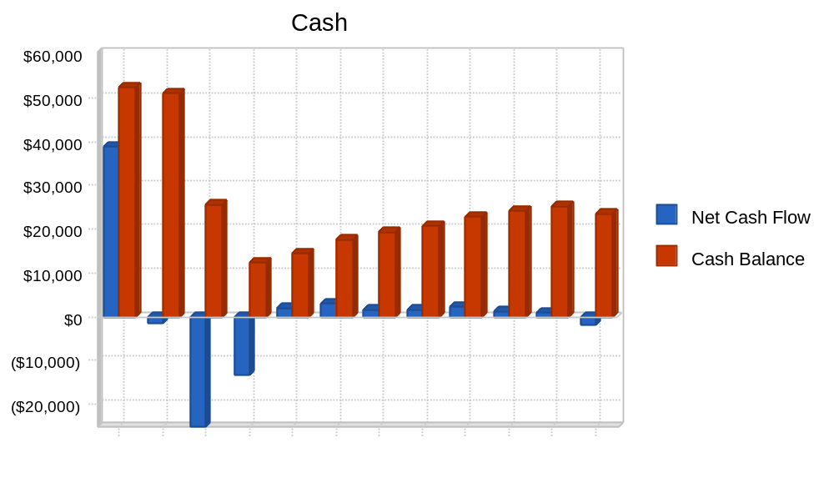

8.6 Projected Balance Sheet
The table below summarizes our balance sheet projections. Our asset base will grow through accumulated cash balances. As mentioned earlier in this business plan, we also plan to re-pay the no-interest loans in equal installments over three years. This should allow us to end 2004 with a solid accounting net worth, which should then steadily grow over the next two years.

Table: Balance Sheet

Pro Forma Balance Sheet
 | 2004 | 2005 | 2006
Assets
Current Assets
Cash | $23,362 | $24,803 | $43,548
Inventory | $9,112 | $14,925 | $14,859
Other Current Assets | $0 | $0 | $0
Total Current Assets | $32,474 | $39,728 | $58,407
Long-term Assets
Long-term Assets | $50,055 | $50,055 | $50,055
Accumulated Depreciation | $2,452 | $4,121 | $5,789
Total Long-term Assets | $47,603 | $45,934 | $44,266
Total Assets | $80,077 | $85,662 | $102,673
Liabilities and Capital | 2004 | 2005 | 2006
Current Liabilities
Accounts Payable | $9,994 | $9,839 | $11,369
Current Borrowing | $0 | $0 | $0
Other Current Liabilities | $13,330 | $6,660 | $0
Subtotal Current Liabilities | $23,324 | $16,499 | $11,369
Long-term Liabilities | $34,996 | $29,496 | $23,496
Total Liabilities | $58,320 | $45,995 | $34,865
Paid-in Capital | $1,000 | $1,000 | $1,000
Retained Earnings | $8,807 | $20,757 | $38,667
Earnings | $11,950 | $17,910 | $28,141
Total Capital | $21,757 | $39,667 | $67,808
Total Liabilities and Capital | $80,077 | $85,662 | $102,673
Net Worth | $21,757 | $39,667 | $67,808

Table: Sales Forecast

Sales Forecast
 |  | Jan | Feb | Mar | Apr | May | Jun | Jul | Aug | Sep | Oct | Nov | Dec
Sales
Web Sales |  | $990 | $449 | $1,782 | $3,003 | $3,340 | $5,980 | $7,300 | $7,300 | $7,300 | $7,300 | $7,300 | $7,300
Road Shows |  | $0 | $1,375 | $2,200 | $3,300 | $4,675 | $4,675 | $4,675 | $4,675 | $6,875 | $8,250 | $8,250 | $8,250
Web Design |  | $1,375 | $1,375 | $825 | $825 | $825 | $825 | $825 | $825 | $825 | $825 | $825 | $825
Total Sales |  | $2,365 | $3,199 | $4,807 | $7,128 | $8,840 | $11,480 | $12,800 | $12,800 | $15,000 | $16,375 | $16,375 | $16,375
Direct Cost of Sales |  | Jan | Feb | Mar | Apr | May | Jun | Jul | Aug | Sep | Oct | Nov | Dec
Web Sales |  | $445 | $202 | $800 | $1,348 | $1,499 | $2,685 | $3,278 | $3,278 | $3,278 | $3,278 | $3,278 | $3,278
Road Shows |  | $0 | $825 | $1,320 | $1,980 | $2,805 | $2,805 | $2,805 | $2,805 | $4,125 | $4,950 | $4,950 | $4,950
Web Design |  | $94 | $94 | $56 | $56 | $56 | $56 | $56 | $56 | $56 | $56 | $56 | $56
Subtotal Direct Cost of Sales |  | $538 | $1,120 | $2,176 | $3,384 | $4,361 | $5,546 | $6,139 | $6,139 | $7,459 | $8,284 | $8,284 | $8,284

Table: Personnel

Personnel Plan
 |  | Jan | Feb | Mar | Apr | May | Jun | Jul | Aug | Sep | Oct | Nov | Dec
Gwen Hultquist, Owner/Manager | 0% | $1,000 | $1,000 | $1,000 | $1,000 | $1,000 | $1,000 | $1,000 | $1,000 | $1,000 | $1,000 | $1,000 | $1,000
Tim Hultquist, Co-Owner | 0% | $1,000 | $1,000 | $1,000 | $1,000 | $1,000 | $1,000 | $1,000 | $1,000 | $1,000 | $1,000 | $1,000 | $1,000
General Labor | 0% | $0 | $0 | $0 | $0 | $0 | $0 | $0 | $0 | $1,806 | $1,806 | $1,806 | $1,806
Total People |  | 2 | 2 | 2 | 2 | 2 | 2 | 2 | 2 | 4 | 4 | 4 | 4
Total Payroll |  | $2,000 | $2,000 | $2,000 | $2,000 | $2,000 | $2,000 | $2,000 | $2,000 | $3,806 | $3,806 | $3,806 | $3,806

Table: Profit and Loss

Pro Forma Profit and Loss
 |  | Jan | Feb | Mar | Apr | May | Jun | Jul | Aug | Sep | Oct | Nov | Dec
Sales |  | $2,365 | $3,199 | $4,807 | $7,128 | $8,840 | $11,480 | $12,800 | $12,800 | $15,000 | $16,375 | $16,375 | $16,375
Direct Cost of Sales |  | $538 | $1,120 | $2,176 | $3,384 | $4,361 | $5,546 | $6,139 | $6,139 | $7,459 | $8,284 | $8,284 | $8,284
Other Costs of Goods |  | $0 | $0 | $0 | $0 | $0 | $0 | $0 | $0 | $0 | $0 | $0 | $0
Total Cost of Sales |  | $538 | $1,120 | $2,176 | $3,384 | $4,361 | $5,546 | $6,139 | $6,139 | $7,459 | $8,284 | $8,284 | $8,284
Gross Margin |  | $1,827 | $2,079 | $2,631 | $3,744 | $4,479 | $5,934 | $6,661 | $6,661 | $7,541 | $8,091 | $8,091 | $8,091
Gross Margin % |  | 77.25% | 64.99% | 54.73% | 52.52% | 50.67% | 51.69% | 52.04% | 52.04% | 50.27% | 49.41% | 49.41% | 49.41%
Expenses
Payroll |  | $2,000 | $2,000 | $2,000 | $2,000 | $2,000 | $2,000 | $2,000 | $2,000 | $3,806 | $3,806 | $3,806 | $3,806
Sales and Marketing and Other Expenses |  | $50 | $50 | $50 | $50 | $50 | $50 | $50 | $50 | $50 | $50 | $50 | $50
Depreciation |  | $35 | $35 | $35 | $35 | $139 | $139 | $139 | $139 | $139 | $139 | $139 | $139
Mortgage % for Business-only Areas |  | $350 | $350 | $350 | $350 | $350 | $350 | $350 | $350 | $350 | $350 | $350 | $350
Telephone & Utilities |  | $250 | $250 | $250 | $250 | $250 | $250 | $250 | $250 | $250 | $250 | $250 | $250
Insurance |  | $71 | $0 | $0 | $0 | $0 | $72 | $72 | $72 | $72 | $72 | $72 | $72
Payroll Taxes | 15% | $0 | $0 | $0 | $0 | $0 | $0 | $0 | $0 | $0 | $0 | $0 | $0
Web Store & Internet |  | $70 | $70 | $70 | $70 | $70 | $70 | $70 | $70 | $70 | $70 | $70 | $70
Maintenance & Repair |  | $63 | $63 | $63 | $63 | $63 | $63 | $63 | $63 | $63 | $63 | $63 | $63
Business Supplies |  | $25 | $25 | $25 | $25 | $25 | $25 | $25 | $25 | $25 | $25 | $25 | $25
Professional Services | 15% | $50 | $50 | $50 | $50 | $50 | $50 | $50 | $50 | $50 | $50 | $50 | $50
Expensed Barn Renovations | 15% | $0 | $2,500 | $0 | $0 | $0 | $0 | $0 | $0 | $0 | $0 | $0 | $0
Miscellaneous |  | $25 | $25 | $25 | $25 | $25 | $25 | $25 | $25 | $25 | $25 | $25 | $25
Total Operating Expenses |  | $2,989 | $5,418 | $2,918 | $2,918 | $3,022 | $3,094 | $3,094 | $3,094 | $4,900 | $4,900 | $4,900 | $4,900
Profit Before Interest and Taxes |  | ($1,162) | ($3,339) | ($287) | $826 | $1,457 | $2,840 | $3,567 | $3,567 | $2,641 | $3,191 | $3,191 | $3,191
EBITDA |  | ($1,127) | ($3,304) | ($252) | $861 | $1,596 | $2,979 | $3,706 | $3,706 | $2,780 | $3,330 | $3,330 | $3,330
Interest Expense |  | $231 | $228 | $226 | $224 | $221 | $219 | $216 | $214 | $211 | $209 | $207 | $204
Taxes Incurred |  | ($418) | ($1,070) | ($154) | $181 | $371 | $786 | $1,005 | $1,006 | $729 | $895 | $895 | $896
Net Profit |  | ($975) | ($2,497) | ($359) | $421 | $865 | $1,835 | $2,345 | $2,347 | $1,701 | $2,087 | $2,089 | $2,091
Net Profit/Sales |  | -41.23% | -78.07% | -7.47% | 5.91% | 9.79% | 15.98% | 18.32% | 18.34% | 11.34% | 12.75% | 12.76% | 12.77%

Table: Cash Flow

Pro Forma Cash Flow
 |  | Jan | Feb | Mar | Apr | May | Jun | Jul | Aug | Sep | Oct | Nov | Dec
Cash Received
Cash from Operations
Cash Sales |  | $2,365 | $3,199 | $4,807 | $7,128 | $8,840 | $11,480 | $12,800 | $12,800 | $15,000 | $16,375 | $16,375 | $16,375
Subtotal Cash from Operations |  | $2,365 | $3,199 | $4,807 | $7,128 | $8,840 | $11,480 | $12,800 | $12,800 | $15,000 | $16,375 | $16,375 | $16,375
Additional Cash Received
Sales Tax, VAT, HST/GST Received | 0.00% | $0 | $0 | $0 | $0 | $0 | $0 | $0 | $0 | $0 | $0 | $0 | $0
New Current Borrowing |  | $0 | $0 | $0 | $0 | $0 | $0 | $0 | $0 | $0 | $0 | $0 | $0
New Other Liabilities (interest-free) |  | $0 | $0 | $0 | $0 | $0 | $0 | $0 | $0 | $0 | $0 | $0 | $0
New Long-term Liabilities |  | $40,000 | $0 | $0 | $0 | $0 | $0 | $0 | $0 | $0 | $0 | $0 | $0
Sales of Other Current Assets |  | $0 | $0 | $0 | $0 | $0 | $0 | $0 | $0 | $0 | $0 | $0 | $0
Sales of Long-term Assets |  | $0 | $0 | $0 | $0 | $0 | $0 | $0 | $0 | $0 | $0 | $0 | $0
New Investment Received |  | $0 | $0 | $0 | $0 | $0 | $0 | $0 | $0 | $0 | $0 | $0 | $0
Subtotal Cash Received |  | $42,365 | $3,199 | $4,807 | $7,128 | $8,840 | $11,480 | $12,800 | $12,800 | $15,000 | $16,375 | $16,375 | $16,375
Expenditures |  | Jan | Feb | Mar | Apr | May | Jun | Jul | Aug | Sep | Oct | Nov | Dec
Expenditures from Operations
Cash Spending |  | $2,000 | $2,000 | $2,000 | $2,000 | $2,000 | $2,000 | $2,000 | $2,000 | $3,806 | $3,806 | $3,806 | $3,806
Bill Payments |  | $1,227 | $826 | $2,588 | $3,966 | $4,339 | $5,949 | $8,815 | $8,945 | $8,396 | $10,821 | $11,219 | $10,340
Subtotal Spent on Operations |  | $3,227 | $2,826 | $4,588 | $5,966 | $6,339 | $7,949 | $10,815 | $10,945 | $12,202 | $14,627 | $15,025 | $14,146
Additional Cash Spent
Sales Tax, VAT, HST/GST Paid Out |  | $0 | $0 | $0 | $0 | $0 | $0 | $0 | $0 | $0 | $0 | $0 | $0
Principal Repayment of Current Borrowing |  | $0 | $0 | $0 | $0 | $0 | $0 | $0 | $0 | $0 | $0 | $0 | $0
Other Liabilities Principal Repayment |  | $0 | $0 | $0 | $3,000 | $0 | $0 | $0 | $0 | $0 | $0 | $0 | $3,670
Long-term Liabilities Principal Repayment |  | $417 | $417 | $417 | $417 | $417 | $417 | $417 | $417 | $417 | $417 | $417 | $417
Purchase Other Current Assets |  | $0 | $0 | $0 | $0 | $0 | $0 | $0 | $0 | $0 | $0 | $0 | $0
Purchase Long-term Assets |  | $0 | $1,500 | $25,000 | $11,000 | $0 | $0 | $0 | $0 | $0 | $0 | $0 | $0
Dividends |  | $0 | $0 | $0 | $0 | $0 | $0 | $0 | $0 | $0 | $0 | $0 | $0
Subtotal Cash Spent |  | $3,644 | $4,743 | $30,005 | $20,383 | $6,756 | $8,366 | $11,232 | $11,362 | $12,619 | $15,044 | $15,442 | $18,233
Net Cash Flow |  | $38,721 | ($1,545) | ($25,198) | ($13,255) | $2,083 | $3,113 | $1,568 | $1,437 | $2,380 | $1,331 | $932 | ($1,859)
Cash Balance |  | $52,374 | $50,830 | $25,632 | $12,376 | $14,460 | $17,573 | $19,140 | $20,578 | $22,958 | $24,289 | $25,221 | $23,362

Table: Balance Sheet

Pro Forma Balance Sheet
 |  | Jan | Feb | Mar | Apr | May | Jun | Jul | Aug | Sep | Oct | Nov | Dec
Assets | Starting Balances
Current Assets
Cash | $13,653 | $52,374 | $50,830 | $25,632 | $12,376 | $14,460 | $17,573 | $19,140 | $20,578 | $22,958 | $24,289 | $25,221 | $23,362
Inventory | $6,000 | $5,462 | $4,342 | $5,166 | $4,781 | $4,797 | $6,101 | $6,752 | $6,752 | $8,204 | $9,112 | $9,112 | $9,112
Other Current Assets | $0 | $0 | $0 | $0 | $0 | $0 | $0 | $0 | $0 | $0 | $0 | $0 | $0
Total Current Assets | $19,653 | $57,836 | $55,172 | $30,797 | $17,158 | $19,256 | $23,673 | $25,893 | $27,330 | $31,162 | $33,401 | $34,333 | $32,474
Long-term Assets
Long-term Assets | $12,555 | $12,555 | $14,055 | $39,055 | $50,055 | $50,055 | $50,055 | $50,055 | $50,055 | $50,055 | $50,055 | $50,055 | $50,055
Accumulated Depreciation | $1,200 | $1,235 | $1,270 | $1,305 | $1,340 | $1,479 | $1,618 | $1,757 | $1,896 | $2,035 | $2,174 | $2,313 | $2,452
Total Long-term Assets | $11,355 | $11,320 | $12,785 | $37,750 | $48,715 | $48,576 | $48,437 | $48,298 | $48,159 | $48,020 | $47,881 | $47,742 | $47,603
Total Assets | $31,008 | $69,157 | $67,957 | $68,548 | $65,873 | $67,833 | $72,111 | $74,191 | $75,489 | $79,182 | $81,282 | $82,075 | $80,077
Liabilities and Capital |  | Jan | Feb | Mar | Apr | May | Jun | Jul | Aug | Sep | Oct | Nov | Dec
Current Liabilities
Accounts Payable | $1,201 | $742 | $2,456 | $3,823 | $4,144 | $5,656 | $8,516 | $8,668 | $8,036 | $10,446 | $10,875 | $9,996 | $9,994
Current Borrowing | $0 | $0 | $0 | $0 | $0 | $0 | $0 | $0 | $0 | $0 | $0 | $0 | $0
Other Current Liabilities | $20,000 | $20,000 | $20,000 | $20,000 | $17,000 | $17,000 | $17,000 | $17,000 | $17,000 | $17,000 | $17,000 | $17,000 | $13,330
Subtotal Current Liabilities | $21,201 | $20,742 | $22,456 | $23,823 | $21,144 | $22,656 | $25,516 | $25,668 | $25,036 | $27,446 | $27,875 | $26,996 | $23,324
Long-term Liabilities | $0 | $39,583 | $39,166 | $38,749 | $38,332 | $37,915 | $37,498 | $37,081 | $36,664 | $36,247 | $35,830 | $35,413 | $34,996
Total Liabilities | $21,201 | $60,325 | $61,622 | $62,572 | $59,476 | $60,571 | $63,014 | $62,749 | $61,700 | $63,693 | $63,705 | $62,409 | $58,320
Paid-in Capital | $1,000 | $1,000 | $1,000 | $1,000 | $1,000 | $1,000 | $1,000 | $1,000 | $1,000 | $1,000 | $1,000 | $1,000 | $1,000
Retained Earnings | ($19,350) | $8,807 | $8,807 | $8,807 | $8,807 | $8,807 | $8,807 | $8,807 | $8,807 | $8,807 | $8,807 | $8,807 | $8,807
Earnings | $28,157 | ($975) | ($3,472) | ($3,832) | ($3,410) | ($2,545) | ($710) | $1,635 | $3,982 | $5,683 | $7,770 | $9,859 | $11,950
Total Capital | $9,807 | $8,832 | $6,335 | $5,975 | $6,397 | $7,262 | $9,097 | $11,442 | $13,789 | $15,490 | $17,577 | $19,666 | $21,757
Total Liabilities and Capital | $31,008 | $69,157 | $67,957 | $68,548 | $65,873 | $67,833 | $72,111 | $74,191 | $75,489 | $79,182 | $81,282 | $82,075 | $80,077
Net Worth | $9,807 | $8,832 | $6,335 | $5,975 | $6,397 | $7,262 | $9,097 | $11,442 | $13,789 | $15,490 | $17,577 | $19,666 | $21,757



